

***Final Assignment***

**Name:** Taha Rehman

**Roll No:** 2023-BS-Ai-090

**Department:** AI

**Sec:** A

**Semester:** III

**Doubly Linked List**

**Problem1:** Write a program to delete the first node in a doubly linked list.

**Code:**

#include <iostream>

using namespace std;

class Node {

public:

int val;

Node* next;

Node* prev;

Node(int data) {

val = data;

next = NULL;

prev = NULL;

}

};

class DOUBLELINKLIST {

public:

Node* head;

Node* tail;

DOUBLELINKLIST() {

head = NULL;

tail = NULL;

}

void insert(int val) {

Node* new_node = new Node(val);

if (head == NULL) { // If the list is empty

head = new_node;

tail = new_node;

} else {

tail->next = new_node; // Link the current tail to the new node

new_node->prev = tail; // Link the new node back to the current tail

tail = new_node; // Update the tail to the new node

}

}

void deleteAThead() {

if (head == NULL) { // If the list is empty

return;

}

Node* temp = head;

head = head->next;

if (head == NULL) { // If the list becomes empty after deletion

tail = NULL;

} else {

head->prev = NULL;

}

delete temp;

}

void display() {

Node* temp = head;

while (temp != NULL) {

cout << temp->val;

if (temp->next != NULL) { // Only add <-> between nodes

cout << " <-> ";

}

temp = temp->next;

}

cout << endl;

}

};

int main() {

DOUBLELINKLIST dll;

dll.insert(3);

dll.insert(2);

dll.deleteAThead();

dll.display();

return 0;

}

**Output:**

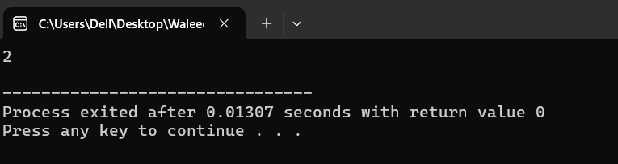

**Problem 2:** How can you delete the last node in a doubly linked list? Write the code

**Code:**

#include <iostream>

using namespace std;

class Node {

public:

int val;

Node* next;

Node* prev;

Node(int data) {

val = data;

next = NULL;

prev = NULL;

}

};

class DOUBLELINKLIST {

public:

Node* head;

Node* tail;

DOUBLELINKLIST() {

head = NULL;

tail = NULL;

}

void insert(int val) {

Node* new_node = new Node(val);

if (head == NULL) { // If the list is empty

head = new_node;

tail = new_node;

} else {

tail->next = new_node; // Link the current tail to the new node

new_node->prev = tail; // Link the new node back to the current tail

tail = new_node; // Update the tail to the new node

}

}

void del(){

if (head==NULL){

return;

}

Node* temp = tail;

tail = tail->prev;

if(head==NULL){

tail=NULL;

}

else{

tail->next = NULL;

}

delete temp;

}

void display() {

Node* temp = head;

while (temp != NULL) {

cout << temp->val;

if (temp->next != NULL) { // Only add <-> between nodes

cout << " <-> ";

}

temp = temp->next;

}

cout << endl;

}

};

int main() {

DOUBLELINKLIST dll;

dll.insert(3);

dll.insert(2);

dll.del();

dll.display();

return 0;

}

**Output:**

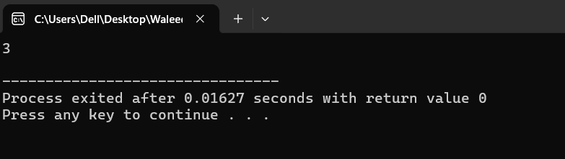

**Problem 3:** Write code to delete a node by its value in a doubly linked list.

**Code:**

#include <iostream>

using namespace std;

// Node structure

struct Node {

int data;

Node* prev;

Node* next;

Node(int value) : data(value), prev(nullptr), next(nullptr) {}

};

// Function to delete a node by its value

void deleteNodeByValue(Node*& head, int value) {

if (head == nullptr) {

cout << "The list is empty. Nothing to delete.\n";

return;

}

Node* current = head;

// Traverse the list to find the node with the given value

while (current != nullptr && current->data != value) {

current = current->next;

}

// If the value is not found

if (current == nullptr) {

cout << "Value " << value << " not found in the list.\n";

return;

}

// If the node to be deleted is the head node

if (current == head) {

head = current->next; // Move head to the next node

if (head != nullptr) {

head->prev = nullptr; // Update the new head's prev pointer

}

} else {

// Update the pointers of the previous and next nodes

if (current->prev != nullptr) {

current->prev->next = current->next;

}

if (current->next != nullptr) {

current->next->prev = current->prev;

}

}

delete current; // Free the memory of the deleted node

cout << "Node with value " << value << " deleted successfully.\n";

}

// Function to display the list

void displayList(Node* head) {

if (head == nullptr) {

cout << "The list is empty.\n";

return;

}

Node* temp = head;

while (temp != nullptr) {

cout << temp->data << " ";

temp = temp->next;

}

cout << endl;

}

// Function to append a new node to the end of the list

void appendNode(Node*& head, int value) {

Node* newNode = new Node(value);

if (head == nullptr) {

head = newNode;

return;

}

Node* temp = head;

while (temp->next != nullptr) {

temp = temp->next;

}

temp->next = newNode;

newNode->prev = temp;

}

int main() {

Node* head = nullptr;

// Append some nodes to the list

appendNode(head, 10);

appendNode(head, 20);

appendNode(head, 30);

appendNode(head, 40);

cout << "Original list: ";

displayList(head);

// Delete a node by its value

deleteNodeByValue(head, 20);

cout << "List after deleting node with value 20: ";

displayList(head);

// Attempt to delete a value not in the list

deleteNodeByValue(head, 50);

cout << "Final list: ";

displayList(head);

return 0;

}

**Output:**

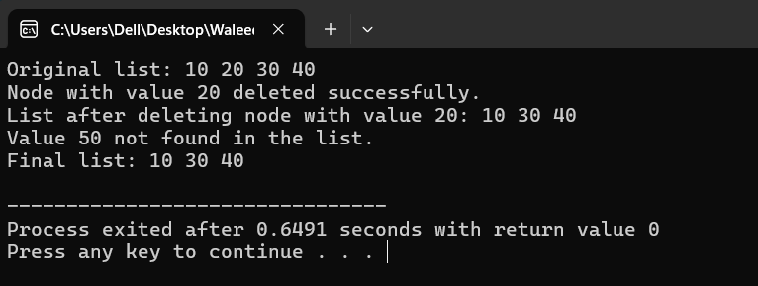

**Problem 4:** How would you delete a node at a specific position in a doubly linked list? Show it in code.

**Code:**

#include <iostream>

using namespace std;

class Node {

public:

int val;

Node* next;

Node* prev;

Node(int data) {

val = data;

next = NULL;

prev = NULL;

}

};

class DOUBLELINKLIST {

public:

Node* head;

Node* tail;

DOUBLELINKLIST() {

head = NULL;

tail = NULL;

}

void insert(int val) {

Node* new_node = new Node(val);

if (head == NULL) {

head = new_node;

tail = new_node;

} else {

tail->next = new_node;

new_node->prev = tail;

tail = new_node;

}

}

void del(int p) {

if (head == NULL) {

cout << "List is empty." << endl;

return;

}

Node* temp = head;

int count = 1;

while (temp != NULL && count < p) {

temp = temp->next;

count++;

}

if (temp == NULL) {

cout << "Position out of bounds." << endl;

return;

}

if (temp->prev != NULL)

temp->prev->next = temp->next;

if (temp->next != NULL)

temp->next->prev = temp->prev;

if (temp == head)

head = temp->next;

if (temp == tail)

tail = temp->prev;

delete temp;

}

void display() {

Node* temp = head;

while (temp != NULL) {

cout << temp->val;

if (temp->next != NULL) {

cout << " <-> ";

}

temp = temp->next;

}

cout << endl;

}

};

int main() {

DOUBLELINKLIST dll;

dll.insert(3);

dll.insert(2);

dll.insert(1);

dll.del(2);

dll.display();

return 0;

}

**Output:**

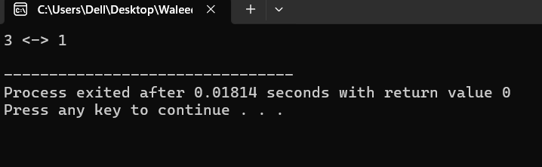

**Problem 5:** After deleting a node, how will you write the forward and reverse traversal functions?

**Code:**

#include <iostream>

using namespace std;

// Node structure

struct Node {

int data;

Node* prev;

Node* next;

Node(int value) : data(value), prev(nullptr), next(nullptr) {}

};

// Function to delete a node at a specific position

void deleteNodeAtPosition(Node*& head, int position) {

if (head == nullptr) {

cout << "The list is empty. Nothing to delete.\n";

return;

}

if (position <= 0) {

cout << "Invalid position. Position must be greater than 0.\n";

return;

}

Node* current = head;

// Traverse to the desired position

int index = 1; // 1-based index

while (current != nullptr && index < position) {

current = current->next;

index++;

}

// If position is out of bounds

if (current == nullptr) {

cout << "Position " << position << " is out of bounds.\n";

return;

}

// Update pointers to exclude the current node

if (current->prev != nullptr) {

current->prev->next = current->next;

} else {

head = current->next; // Update head if the first node is being deleted

}

if (current->next != nullptr) {

current->next->prev = current->prev;

}

delete current; // Free memory of the deleted node

cout << "Node at position " << position << " deleted successfully.\n";

}

// Function to append a new node to the end of the list

void appendNode(Node*& head, int value) {

Node* newNode = new Node(value);

if (head == nullptr) {

head = newNode;

return;

}

Node* temp = head;

while (temp->next != nullptr) {

temp = temp->next;

}

temp->next = newNode;

newNode->prev = temp;

}

// Forward traversal function

void forwardTraversal(Node* head) {

if (head == nullptr) {

cout << "The list is empty.\n";

return;

}

Node* temp = head;

cout << "Forward Traversal: ";

while (temp != nullptr) {

cout << temp->data << " ";

temp = temp->next;

}

cout << endl;

}

// Reverse traversal function

void reverseTraversal(Node* head) {

if (head == nullptr) {

cout << "The list is empty.\n";

return;

}

// Find the tail of the list

Node* temp = head;

while (temp->next != nullptr) {

temp = temp->next;

}

// Traverse backward from the tail to the head

cout << "Reverse Traversal: ";

while (temp != nullptr) {

cout << temp->data << " ";

temp = temp->prev;

}

cout << endl;

}

int main() {

Node* head = nullptr;

// Append some nodes to the list

appendNode(head, 10);

appendNode(head, 20);

appendNode(head, 30);

appendNode(head, 40);

appendNode(head, 50);

cout << "Original list:\n";

forwardTraversal(head);

reverseTraversal(head);

// Delete a node at position 3

deleteNodeAtPosition(head, 3);

cout << "After deleting node at position 3:\n";

forwardTraversal(head);

reverseTraversal(head);

return 0;

}

**Output:**

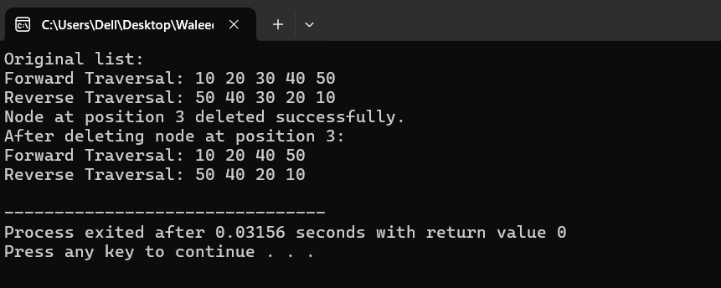

**Circular Linked List**

**Problem 1:** Write a program to delete the first node in a circular linked list.

**Code:**

#include <iostream>

using namespace std;

class Node {

public:

int val;

Node* next;

Node(int data) {

val = data;

next = NULL;

}

};

class Circular {

public:

Node* head;

Circular() {

head = NULL;

}

void insert(int data) {

Node* newNode = new Node(data);

if (head == NULL) {

head = newNode;

newNode->next = head;

} else {

Node* temp = head;

while (temp->next != head) {

temp = temp->next;

}

temp->next = newNode;

newNode->next = head;

head = newNode;

}

}

void deleteATstart(){

if (head == NULL){

return;

}

Node* temp = head;

Node* tail = head;

while (tail->next != head){

tail = tail->next;

}

head = head->next;

tail->next = head;

delete temp;

}

void display() {

if (head == NULL) {

cout << "The list is empty." << endl;

return;

}

Node* temp = head;

do {

cout << temp->val << " -> ";

temp = temp->next;

} while (temp != head);

cout << "(head)" << endl;

}

};

int main() {

Circular cc;

cc.insert(3);

cc.insert(2);

cc.display();

cc.deleteATstart();

cc.display();

return 0;

}

**Output:**

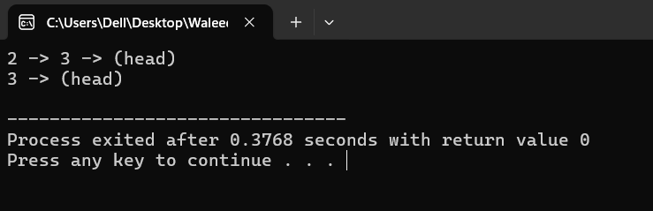

**Problem 2:** How can you delete the last node in a circular linked list? Write the code.

**Code:**

#include <iostream>

using namespace std;

class Node {

public:

int val;

Node* next;

Node(int data) {

val = data;

next = NULL;

}

};

class Circular {

public:

Node* head;

Circular() {

head = NULL;

}

void insert(int data) {

Node* newNode = new Node(data);

if (head == NULL) {

head = newNode;

newNode->next = head;

} else {

Node* temp = head;

while (temp->next != head) {

temp = temp->next;

}

temp->next = newNode;

newNode->next = head;

}

}

void deleteATstart(){

if (head == NULL){

return;

}

Node* temp = head;

Node* tail = head;

while (tail->next != head){

tail = tail->next;

}

head = head->next;

tail->next = head;

delete temp;

}

void deleteTail(){

if (head == NULL){

return;

}

Node* tail = head;

while (tail->next->next != head){

tail = tail->next;

}

Node* temp = tail->next;

tail->next = head;

delete temp;

}

void display() {

if (head == NULL) {

cout << "The list is empty." << endl;

return;

}

Node* temp = head;

do {

cout << temp->val << " -> ";

temp = temp->next;

} while (temp != head);

cout << "(head)" << endl;

}

};

int main() {

Circular cc;

cc.insert(3);

cc.insert(2);

cc.display();

cc.deleteTail();

cc.display();

return 0;

}

**Output:**

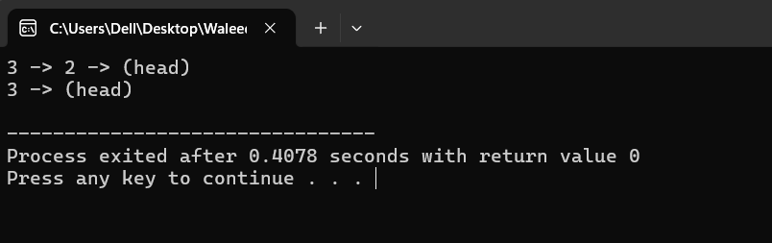

**Problem 3**: Write a function to delete a node by its value in a circular linked list.

**Code:**

#include <iostream>

using namespace std;

// Node structure

struct Node {

int data;

Node* next;

Node(int value) : data(value), next(nullptr) {}

};

// Function to delete a node by its value

void deleteNodeByValue(Node*& head, int value) {

if (head == nullptr) {

cout << "The list is empty. Nothing to delete.\n";

return;

}

Node* current = head;

Node* prev = nullptr;

// If the list contains only one node

if (head->data == value && head->next == head) {

delete head;

head = nullptr;

cout << "Node with value " << value << " deleted successfully.\n";

return;

}

// Traverse the list to find the node with the given value

do {

if (current->data == value) {

if (prev == nullptr) { // Node to delete is the head

Node* tail = head;

while (tail->next != head) { // Find the tail node

tail = tail->next;

}

// Update head and tail pointers

tail->next = head->next;

Node* temp = head;

head = head->next;

delete temp;

} else { // Node to delete is not the head

prev->next = current->next;

delete current;

}

cout << "Node with value " << value << " deleted successfully.\n";

return;

}

prev = current;

current = current->next;

} while (current != head);

cout << "Value " << value << " not found in the list.\n";

}

// Function to append a node to the circular linked list

void appendNode(Node*& head, int value) {

Node* newNode = new Node(value);

if (head == nullptr) {

head = newNode;

newNode->next = head;

return;

}

Node* temp = head;

while (temp->next != head) {

temp = temp->next;

}

temp->next = newNode;

newNode->next = head;

}

// Function to display the circular linked list

void displayList(Node* head) {

if (head == nullptr) {

cout << "The list is empty.\n";

return;

}

Node* temp = head;

cout << "Circular Linked List: ";

do {

cout << temp->data << " ";

temp = temp->next;

} while (temp != head);

cout << endl;

}

int main() {

Node* head = nullptr;

// Append some nodes to the list

appendNode(head, 10);

appendNode(head, 20);

appendNode(head, 30);

appendNode(head, 40);

cout << "Original list:\n";

displayList(head);

// Delete a node by its value

deleteNodeByValue(head, 20);

cout << "List after deleting node with value 20:\n";

displayList(head);

// Attempt to delete a value not in the list

deleteNodeByValue(head, 50);

// Delete the head node

deleteNodeByValue(head, 10);

cout << "List after deleting head node:\n";

displayList(head);

return 0;

}

**Output:**

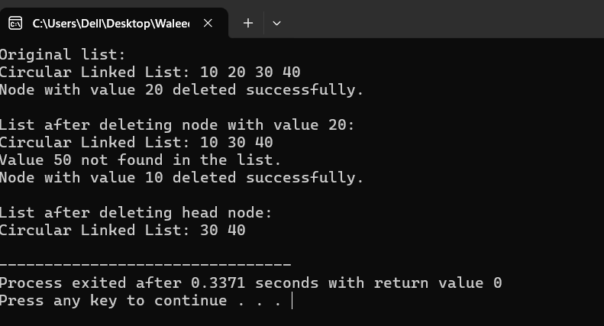

**Problem 4:** How will you delete a node at a specific position in a circular linked list? Write code for it.

**Code:**

#include <iostream>

using namespace std;

// Node structure

struct Node {

int data;

Node* next;

Node(int value) : data(value), next(nullptr) {}

};

// Function to delete a node at a specific position

void deleteNodeAtPosition(Node*& head, int position) {

if (head == nullptr) {

cout << "The list is empty. Nothing to delete.\n";

return;

}

if (position <= 0) {

cout << "Invalid position. Position must be greater than 0.\n";

return;

}

Node* current = head;

Node* prev = nullptr;

// Case 1: Deleting the head node

if (position == 1) {

// Find the last node

Node* tail = head;

while (tail->next != head) {

tail = tail->next;

}

// Update head and adjust pointers

if (head->next == head) { // If only one node in the list

delete head;

head = nullptr;

} else {

tail->next = head->next;

Node* temp = head;

head = head->next;

delete temp;

}

cout << "Node at position 1 deleted successfully.\n";

return;

}

// Case 2: Deleting a node at another position

int index = 1;

while (current->next != head && index < position) {

prev = current;

current = current->next;

index++;

}

if (index < position || current == head) { // Position out of bounds

cout << "Position " << position << " is out of bounds.\n";

return;

}

// Update pointers and delete the node

prev->next = current->next;

delete current;

cout << "Node at position " << position << " deleted successfully.\n";

}

// Function to append a node to the circular linked list

void appendNode(Node*& head, int value) {

Node* newNode = new Node(value);

if (head == nullptr) {

head = newNode;

newNode->next = head;

return;

}

Node* temp = head;

while (temp->next != head) {

temp = temp->next;

}

temp->next = newNode;

newNode->next = head;

}

// Function to display the circular linked list

void displayList(Node* head) {

if (head == nullptr) {

cout << "The list is empty.\n";

return;

}

Node* temp = head;

cout << "Circular Linked List: ";

do {

cout << temp->data << " ";

temp = temp->next;

} while (temp != head);

cout << endl;

}

int main() {

Node* head = nullptr;

// Append some nodes to the list

appendNode(head, 10);

appendNode(head, 20);

appendNode(head, 30);

appendNode(head, 40);

cout << "Original list:\n";

displayList(head);

// Delete a node at position 2

deleteNodeAtPosition(head, 2);

cout << "\nList after deleting node at position 2:\n";

displayList(head);

// Attempt to delete a node at an invalid position

deleteNodeAtPosition(head, 10);

// Delete the head node

deleteNodeAtPosition(head, 1);

cout << "\nList after deleting head node:\n";

displayList(head);

return 0;

}

**Output:**

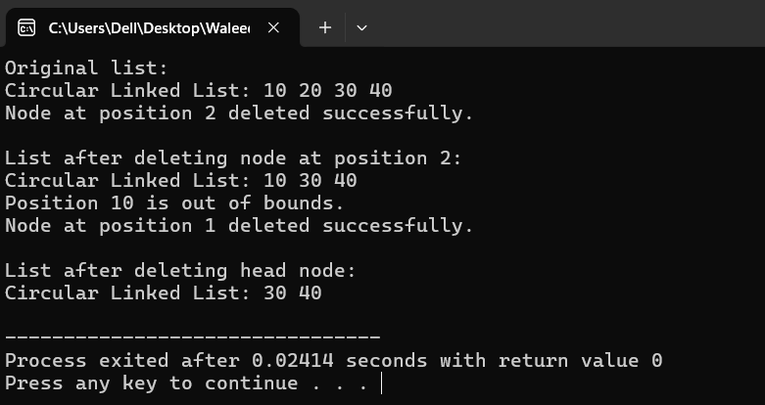

**Problem 5:** Write a program to show forward traversal after deleting a node in a circular linked list.

**Code:**

#include <iostream>

using namespace std;

// Node structure

struct Node {

int data;

Node* next;

Node(int value) : data(value), next(nullptr) {}

};

// Function to delete the head node

void deleteHeadNode(Node*& head) {

if (!head) {

cout << "The list is empty. Nothing to delete.\n";

return;

}

if (head->next == head) { // Single node case

delete head;

head = nullptr;

} else {

Node* tail = head;

while (tail->next != head) tail = tail->next; // Find the tail node

tail->next = head->next;

Node* temp = head;

head = head->next;

delete temp;

}

cout << "Head node deleted successfully.\n";

}

// Function to append a node to the circular linked list

void appendNode(Node*& head, int value) {

Node* newNode = new Node(value);

if (!head) {

head = newNode;

newNode->next = head;

return;

}

Node* temp = head;

while (temp->next != head) temp = temp->next;

temp->next = newNode;

newNode->next = head;

}

// Function to display the circular linked list

void displayList(Node* head) {

if (!head) {

cout << "List is empty.\n";

return;

}

Node* temp = head;

cout << "List: ";

do {

cout << temp->data << " ";

temp = temp->next;

} while (temp != head);

cout << endl;

}

// Main function

int main() {

Node* head = nullptr;

// Append some nodes to the list

appendNode(head, 10);

appendNode(head, 20);

appendNode(head, 30);

appendNode(head, 40);

// Display the original list

cout << "Original list:\n";

displayList(head);

// Delete the head node and display the list after each deletion

deleteHeadNode(head);

cout << "\nList after deleting the head node:\n";

displayList(head);

deleteHeadNode(head);

cout << "\nList after deleting the head node again:\n";

displayList(head);

deleteHeadNode(head);

cout << "\nList after deleting the head node again:\n";

displayList(head);

return 0;

}

**Output:**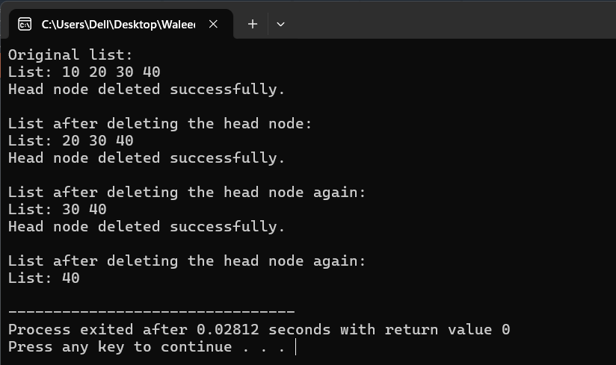

**Binary Search Tree**

**Problem 1**: Write a program to count all the nodes in a binary search tree.

**Code:**

#include <iostream>

using namespace std;

// Node structure

struct Node {

int data;

Node* left;

Node* right;

Node(int value) : data(value), left(nullptr), right(nullptr) {}

};

// Function to insert a node into the BST

Node* insertNode(Node* root, int value) {

if (!root) return new Node(value);

if (value < root->data)

root->left = insertNode(root->left, value);

else

root->right = insertNode(root->right, value);

return root;

}

// Function to count the nodes in the BST

int countNodes(Node* root) {

if (!root) return 0; // Base case: empty tree

// Count the current node + left subtree + right subtree

return 1 + countNodes(root->left) + countNodes(root->right);

}

// Function to display the BST (In-order Traversal)

void inOrderTraversal(Node* root) {

if (!root) return;

inOrderTraversal(root->left);

cout << root->data << " ";

inOrderTraversal(root->right);

}

// Main function

int main() {

Node* root = nullptr;

// Insert nodes into the BST

root = insertNode(root, 50);

root = insertNode(root, 30);

root = insertNode(root, 70);

root = insertNode(root, 20);

root = insertNode(root, 40);

root = insertNode(root, 60);

root = insertNode(root, 80);

// Display the BST

cout << "In-order traversal of the BST: ";

inOrderTraversal(root);

cout << endl;

// Count the nodes

int totalNodes = countNodes(root);

cout << "Total number of nodes in the BST: " << totalNodes << endl;

return 0;

}

**Output:**

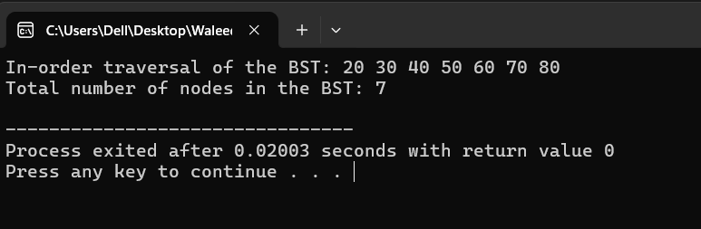

**Problem 2:** How can you search for a specific value in a binary search tree? Write the code

**Code:**

#include <iostream>

using namespace std;

// Define a node of the binary search tree

struct Node {

int data;

Node* left;

Node* right;

Node(int value) : data(value), left(nullptr), right(nullptr) {}

};

// Function to insert a node into the binary search tree

Node* insertNode(Node* root, int value) {

if (root == nullptr) {

return new Node(value);

}

if (value < root->data) {

root->left = insertNode(root->left, value);

} else {

root->right = insertNode(root->right, value);

}

return root;

}

// Function to search for an element in the binary search tree

bool searchNode(Node* root, int value) {

if (root == nullptr) {

return false; // Element not found, root is nullptr

}

if (root->data == value) {

return true; // Element found

}

if (value < root->data) {

return searchNode(root->left, value); // Search in left subtree

} else {

return searchNode(root->right, value); // Search in right subtree

}

}

int main() {

Node* root = nullptr;

// Insert elements into the binary search tree

root = insertNode(root, 50);

root = insertNode(root, 30);

root = insertNode(root, 20);

root = insertNode(root, 40);

root = insertNode(root, 70);

root = insertNode(root, 60);

root = insertNode(root, 80);

// Search for an element

int searchValue = 40;

bool result = searchNode(root, searchValue);

if (result) {

cout << "Element " << searchValue << " exists in the BST." << endl;

} else {

cout << "Element " << searchValue << " does not exist in the BST." << endl;

}

return 0;

}

**Output:**

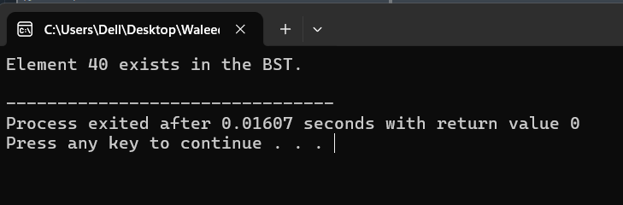

**Problem 3:** Write code to traverse a binary search tree in in-order, pre-order, and post order.

**Code:**

#include <iostream>

using namespace std;

// Node structure

struct Node {

int data;

Node* left;

Node* right;

Node(int value) : data(value), left(nullptr), right(nullptr) {}

};

// Function to insert a node into the BST

Node* insertNode(Node* root, int value) {

if (!root) return new Node(value);

if (value < root->data)

root->left = insertNode(root->left, value);

else

root->right = insertNode(root->right, value);

return root;

}

// In-order Traversal: Left -> Root -> Right

void inOrderTraversal(Node* root) {

if (!root) return;

inOrderTraversal(root->left);

cout << root->data << " ";

inOrderTraversal(root->right);

}

// Pre-order Traversal: Root -> Left -> Right

void preOrderTraversal(Node* root) {

if (!root) return;

cout << root->data << " ";

preOrderTraversal(root->left);

preOrderTraversal(root->right);

}

// Post-order Traversal: Left -> Right -> Root

void postOrderTraversal(Node* root) {

if (!root) return;

postOrderTraversal(root->left);

postOrderTraversal(root->right);

cout << root->data << " ";

}

// Main function

int main() {

Node* root = nullptr;

// Insert nodes into the BST

root = insertNode(root, 50);

root = insertNode(root, 30);

root = insertNode(root, 70);

root = insertNode(root, 20);

root = insertNode(root, 40);

root = insertNode(root, 60);

root = insertNode(root, 80);

// Perform and display all three traversals

cout << "In-order Traversal: ";

inOrderTraversal(root);

cout << endl;

cout << "Pre-order Traversal: ";

preOrderTraversal(root);

cout << endl;

cout << "Post-order Traversal: ";

postOrderTraversal(root);

cout << endl;

return 0;

}

**Output:**

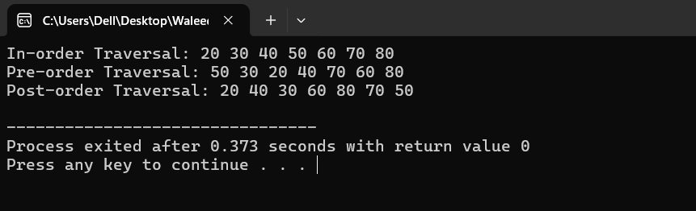

**Problem 4:** How will you write reverse in-order traversal for a binary search tree? Show it in code.

**Code:**

#include <iostream>

using namespace std;

// Node structure

struct Node {

int data;

Node* left;

Node* right;

Node(int value) : data(value), left(nullptr), right(nullptr) {}

};

// Function to insert a node into the BST

Node* insertNode(Node* root, int value) {

if (!root) return new Node(value);

if (value < root->data)

root->left = insertNode(root->left, value);

else

root->right = insertNode(root->right, value);

return root;

}

// Reverse In-order Traversal: Right -> Root -> Left

void reverseInOrderTraversal(Node* root) {

if (!root) return;

reverseInOrderTraversal(root->right); // Visit right subtree

cout << root->data << " "; // Visit root

reverseInOrderTraversal(root->left); // Visit left subtree

}

// Main function

int main() {

Node* root = nullptr;

// Insert nodes into the BST

root = insertNode(root, 50);

root = insertNode(root, 30);

root = insertNode(root, 70);

root = insertNode(root, 20);

root = insertNode(root, 40);

root = insertNode(root, 60);

root = insertNode(root, 80);

// Perform and display the reverse in-order traversal

cout << "Reverse In-order Traversal: ";

reverseInOrderTraversal(root);

cout << endl;

return 0;

}

**Output:**

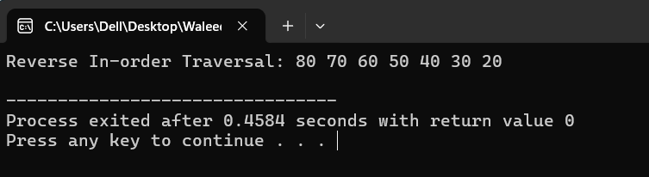

**Problem 5:** Write a program to check if there are duplicate values in a binary search tree.

**Code:**

#include <iostream>

using namespace std;

// Node structure

struct Node {

int data;

Node* left;

Node* right;

Node(int value) : data(value), left(nullptr), right(nullptr) {}

};

// Function to insert a node into the BST

Node* insertNode(Node* root, int value) {

if (!root) return new Node(value);

if (value < root->data)

root->left = insertNode(root->left, value);

else

root->right = insertNode(root->right, value);

return root;

}

// Function to check for duplicates using in-order traversal

bool checkForDuplicates(Node* root, int& prevValue) {

if (!root) return false;

// Check the left subtree

if (checkForDuplicates(root->left, prevValue)) return true;

// Check the current node for duplicate

if (root->data == prevValue) return true;

// Update the previous value with the current node's value

prevValue = root->data;

// Check the right subtree

return checkForDuplicates(root->right, prevValue);

}

// Main function

int main() {

Node* root = nullptr;

// Insert nodes into the BST

root = insertNode(root, 50);

root = insertNode(root, 30);

root = insertNode(root, 70);

root = insertNode(root, 20);

root = insertNode(root, 40);

root = insertNode(root, 60);

root = insertNode(root, 80);

// Inserting a duplicate value to test

root = insertNode(root, 40); // Duplicate value

int prevValue = -1; // Initialize previous value to a value that can't be in the tree

bool hasDuplicates = checkForDuplicates(root, prevValue);

if (hasDuplicates)

cout << "The BST contains duplicate values." << endl;

else

cout << "The BST does not contain duplicate values." << endl;

return 0;

}

**Output:**

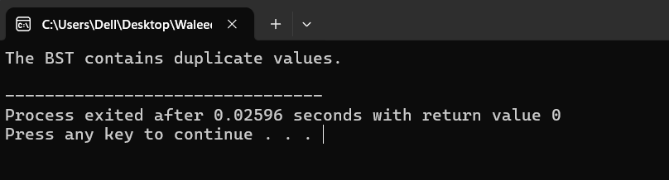

**Problem 6:** How can you delete a node from a binary search tree? Write code for deleting a leaf, a node with one child, and a node with two children.

**Code:**

#include <iostream>

using namespace std;

// Node structure

struct Node {

int data;

Node* left;

Node* right;

Node(int value) : data(value), left(nullptr), right(nullptr) {}

};

// Function to insert a node into the BST

Node* insertNode(Node* root, int value) {

if (!root) return new Node(value);

if (value < root->data)

root->left = insertNode(root->left, value);

else

root->right = insertNode(root->right, value);

return root;

}

// Function to find the minimum node in a subtree (used for finding in-order successor)

Node* findMin(Node* root) {

while (root && root->left)

root = root->left;

return root;

}

// Function to delete a node in a BST

Node* deleteNode(Node* root, int value) {

if (!root) return root;

// If value to be deleted is smaller than root's value, it lies in the left subtree

if (value < root->data)

root->left = deleteNode(root->left, value);

// If value to be deleted is greater than root's value, it lies in the right subtree

else if (value > root->data)

root->right = deleteNode(root->right, value);

// If value is the same as root's value, this is the node to be deleted

else {

// Case 1: Node has no children (leaf node)

if (!root->left && !root->right) {

delete root;

root = nullptr;

}

// Case 2: Node has one child

else if (!root->left) {

Node* temp = root;

root = root->right;

delete temp;

} else if (!root->right) {

Node* temp = root;

root = root->left;

delete temp;

}

// Case 3: Node has two children

else {

Node* temp = findMin(root->right); // Get the in-order successor (smallest in right subtree)

root->data = temp->data; // Replace root's value with in-order successor's value

root->right = deleteNode(root->right, temp->data); // Delete the in-order successor

}

}

return root;

}

// Function to perform in-order traversal

void inOrderTraversal(Node* root) {

if (!root) return;

inOrderTraversal(root->left);

cout << root->data << " ";

inOrderTraversal(root->right);

}

// Main function

int main() {

Node* root = nullptr;

// Insert nodes into the BST

root = insertNode(root, 50);

root = insertNode(root, 30);

root = insertNode(root, 70);

root = insertNode(root, 20);

root = insertNode(root, 40);

root = insertNode(root, 60);

root = insertNode(root, 80);

cout << "In-order traversal of the BST before deletion: ";

inOrderTraversal(root);

cout << endl;

// Delete nodes and perform in-order traversal after each deletion

// Deleting a leaf node (e.g., 20)

root = deleteNode(root, 20);

cout << "In-order traversal after deleting leaf node 20: ";

inOrderTraversal(root);

cout << endl;

// Deleting a node with one child (e.g., 30)

root = deleteNode(root, 30);

cout << "In-order traversal after deleting node with one child (30): ";

inOrderTraversal(root);

cout << endl;

// Deleting a node with two children (e.g., 50)

root = deleteNode(root, 50);

cout << "In-order traversal after deleting node with two children (50): ";

inOrderTraversal(root);

cout << endl;

return 0;

}

**Code:**

#include <iostream>

using namespace std;

// Node structure

struct Node {

int data;

Node* left;

Node* right;

Node(int value) : data(value), left(nullptr), right(nullptr) {}

};

// Function to insert a node into the BST

Node* insertNode(Node* root, int value) {

if (!root) return new Node(value);

if (value < root->data)

root->left = insertNode(root->left, value);

else

root->right = insertNode(root->right, value);

return root;

}

// Function to find the minimum node in a subtree (used for finding in-order successor)

Node* findMin(Node* root) {

while (root && root->left)

root = root->left;

return root;

}

// Function to delete a node in a BST

Node* deleteNode(Node* root, int value) {

if (!root) return root;

// If value to be deleted is smaller than root's value, it lies in the left subtree

if (value < root->data)

root->left = deleteNode(root->left, value);

// If value to be deleted is greater than root's value, it lies in the right subtree

else if (value > root->data)

root->right = deleteNode(root->right, value);

// If value is the same as root's value, this is the node to be deleted

else {

// Case 1: Node has no children (leaf node)

if (!root->left && !root->right) {

delete root;

root = nullptr;

}

// Case 2: Node has one child

else if (!root->left) {

Node* temp = root;

root = root->right;

delete temp;

} else if (!root->right) {

Node* temp = root;

root = root->left;

delete temp;

}

// Case 3: Node has two children

else {

Node* temp = findMin(root->right); // Get the in-order successor (smallest in right subtree)

root->data = temp->data; // Replace root's value with in-order successor's value

root->right = deleteNode(root->right, temp->data); // Delete the in-order successor

}

}

return root;

}

// Function to perform in-order traversal

void inOrderTraversal(Node* root) {

if (!root) return;

inOrderTraversal(root->left);

cout << root->data << " ";

inOrderTraversal(root->right);

}

// Main function

int main() {

Node* root = nullptr;

// Insert nodes into the BST

root = insertNode(root, 50);

root = insertNode(root, 30);

root = insertNode(root, 70);

root = insertNode(root, 20);

root = insertNode(root, 40);

root = insertNode(root, 60);

root = insertNode(root, 80);

cout << "In-order traversal of the BST before deletion: ";

inOrderTraversal(root);

cout << endl;

// Delete nodes and perform in-order traversal after each deletion

// Deleting a leaf node (e.g., 20)

root = deleteNode(root, 20);

cout << "In-order traversal after deleting leaf node 20: ";

inOrderTraversal(root);

cout << endl;

// Deleting a node with one child (e.g., 30)

root = deleteNode(root, 30);

cout << "In-order traversal after deleting node with one child (30): ";

inOrderTraversal(root);

cout << endl;

// Deleting a node with two children (e.g., 50)

root = deleteNode(root, 50);

cout << "In-order traversal after deleting node with two children (50): ";

inOrderTraversal(root);

cout << endl;

return 0;

}

**Output:**

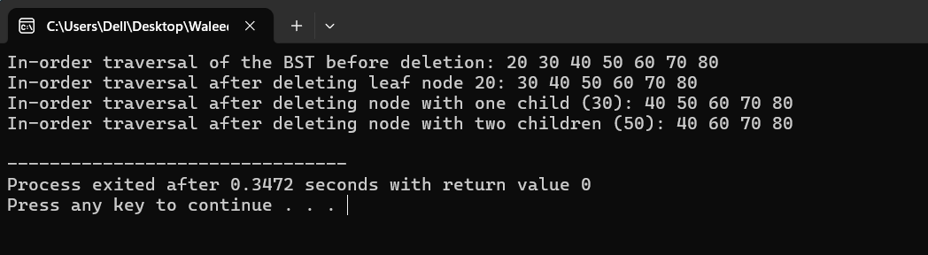

**End of Assignment**

**----------------------------------------------------------------------------------**